5. Online Flight Reservation System
AIM
To design and develop an Online Flight Reservation System using HTML that allows users to search for flights, book tickets, view booking details, cancel tickets, and access flight information through a user-friendly web interface.
PROCEDURE
- Open Visual Studio Code or any text editor.
- Create a new file named index.html.
- Write the HTML code to design the Online Flight Reservation System.
- Create a navigation menu containing Home, Search Flights, Book Ticket, My Tickets, Cancel Ticket, and Customer Feedback.
- Design a flight search form to enter the source, destination, travel date, and travel class.
- Create a booking form to enter passenger details and select the flight.
- Add sections for ticket payment, booking status, ticket printing, and administrator login.
- Save the file with the .html extension.
- Open the file in a web browser to view the flight reservation website.
HTML CODE:
<!DOCTYPE html>
<html lang="en">
<head>
<meta charset="UTF-8">
<meta name="viewport" content="width=device-width, initial-scale=1.0">
<title>Online Flight Reservation System</title>

<style>
body {
font-family: Arial, sans-serif;
margin: 0;
background-color: #f0f5fa;
color: #222;
}

header {
background-color: #003366;
color: white;
text-align: center;
padding: 20px;
}

nav {
background-color: #00509d;
padding: 12px;
text-align: center;
}

nav a {
color: white;
text-decoration: none;
margin: 10px;
font-weight: bold;
}

.container {
max-width: 850px;
margin: 25px auto;
padding: 20px;
}

section {
background-color: white;
padding: 20px;
margin-bottom: 20px;
border-radius: 8px;
box-shadow: 0 2px 8px #cccccc;
}

h2 {
color: #003366;
}

label {
display: block;
margin-top: 12px;
}

input, select, textarea {
width: 100%;
padding: 10px;
margin-top: 5px;
box-sizing: border-box;
border: 1px solid #aaa;
border-radius: 4px;
}

button {
background-color: #00509d;
color: white;
border: none;
padding: 11px 18px;
margin-top: 15px;
border-radius: 4px;
cursor: pointer;
}

button:hover {
background-color: #003366;
}

footer {
text-align: center;
background-color: #003366;
color: white;
padding: 15px;
}

@media (max-width: 600px) {
nav a {
display: inline-block;
margin: 7px;
}
}

@media print {
header, nav, footer, .no-print {
display: none;
}
}
</style>
</head>

<body>

<header>
<h1>Online Flight Reservation System</h1>
<p>Search, Book and Manage Your Flights</p>
</header>

<nav>
<a href="#login">Login</a>
<a href="#search">Search Flights</a>
<a href="#book">Book Ticket</a>
<a href="#tickets">My Tickets</a>
<a href="#cancel">Cancel Ticket</a>
<a href="#feedback">Feedback</a>
<a href="#admin">Admin</a>
</nav>

<div class="container">

<section id="login">
<h2>User Login</h2>
<form>
<label>Email:</label>
<input type="email" placeholder="Enter email" required>

<label>Password:</label>
<input type="password" placeholder="Enter password" required>

<button type="submit">Login</button>
</form>
<p><a href="#forgot">Forgot Password?</a></p>
</section>

<section id="forgot">
<h2>Forgot Password</h2>
<form>
<label>Registered Email:</label>
<input type="email" placeholder="Enter your email" required>
<button type="submit">Reset Password</button>
</form>
</section>

<section id="search">
<h2>Search Flights</h2>
<form>
<label>From:</label>
<input type="text" placeholder="Departure city" required>

<label>To:</label>
<input type="text" placeholder="Destination city" required>

<label>Travel Date:</label>
<input type="date" required>

<label>Travel Class:</label>
<select required>
<option value="">Select Class</option>
<option>Economy</option>
<option>Business</option>
<option>First Class</option>
</select>

<button type="submit">Search Flights</button>
</form>
</section>

<section id="book">
<h2>Book Ticket</h2>
<form>
<label>Flight Number:</label>
<input type="text" placeholder="Enter flight number" required>

<label>Passenger Name:</label>
<input type="text" placeholder="Enter full name" required>

<label>Age:</label>
<input type="number" min="1" max="120" required>

<label>Number of Seats:</label>
<input type="number" min="1" max="9" value="1" required>

<label>Mobile Number:</label>
<input type="tel" placeholder="Enter mobile number" required>

<button type="submit">Book Ticket</button>
</form>
</section>

<section id="payment">
<h2>Ticket Payment</h2>
<form>
<label>Booking ID:</label>
<input type="text" placeholder="Enter booking ID" required>

<label>Payment Method:</label>
<select required>
<option value="">Select Payment Method</option>
<option>UPI</option>
<option>Debit Card</option>
<option>Credit Card</option>
<option>Net Banking</option>
</select>

<button type="submit">Proceed to Payment</button>
</form>
</section>

<section id="tickets">
<h2>My Tickets / Booking Status</h2>
<form>
<label>Booking ID:</label>
<input type="text" placeholder="Enter booking ID" required>
<button type="submit">View Booking</button>
</form>
<button class="no-print" onclick="window.print()">
Print Ticket
</button>
</section>

<section id="cancel">
<h2>Cancel Ticket</h2>
<form>
<label>Booking ID:</label>
<input type="text" placeholder="Enter booking ID" required>

<label>Passenger Name:</label>
<input type="text" placeholder="Enter passenger name" required>

<button type="submit">Cancel Ticket</button>
</form>
</section>

<section id="feedback">
<h2>Customer Feedback</h2>
<form>
<label>Name:</label>
<input type="text" placeholder="Enter your name" required>

<label>Rating:</label>
<select required>
<option value="">Select Rating</option>
<option>Excellent</option>
<option>Good</option>
<option>Average</option>
<option>Poor</option>
</select>

<label>Comments:</label>
<textarea rows="4" placeholder="Write your feedback"></textarea>

<button type="submit">Submit Feedback</button>
</form>
</section>

<section id="admin">
<h2>Administrator Login</h2>
<form>
<label>Admin Username:</label>
<input type="text" placeholder="Enter username" required>

<label>Password:</label>
<input type="password" placeholder="Enter password" required>

<button type="submit">Admin Login</button>
</form>

<h3>Admin Management</h3>
<p>Manage flight schedules, seat availability,
user accounts, reservations and reports.</p>

<button type="button"
onclick="alert('Connect a backend to generate admin reports.')">
View Admin Report
</button>
</section>

</div>

<footer>
<p>&copy; 2026 Online Flight Reservation System</p>
</footer>

</body>
</html>
OUTPUT:
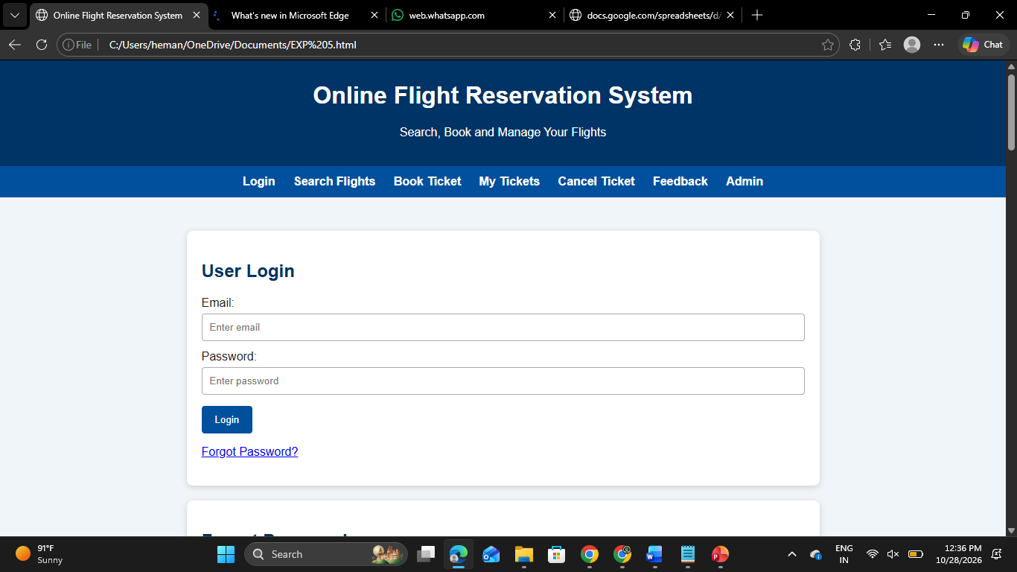
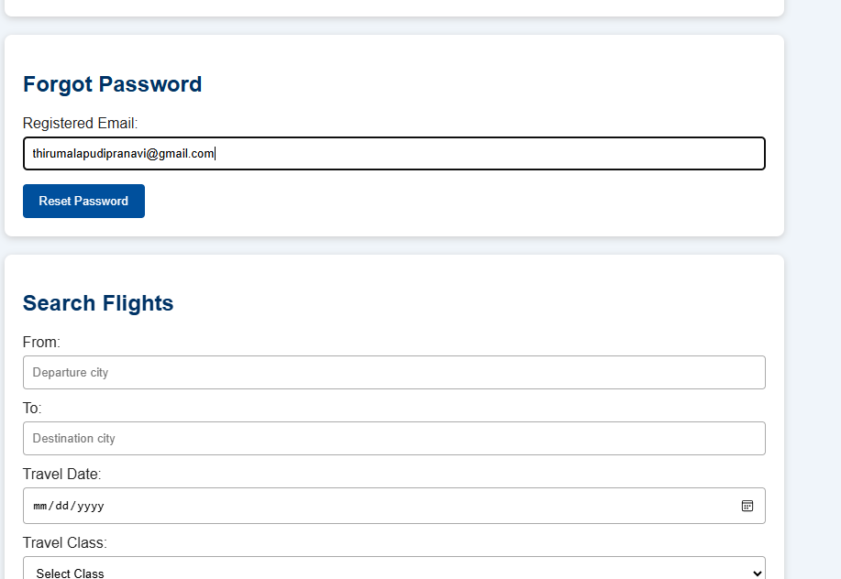
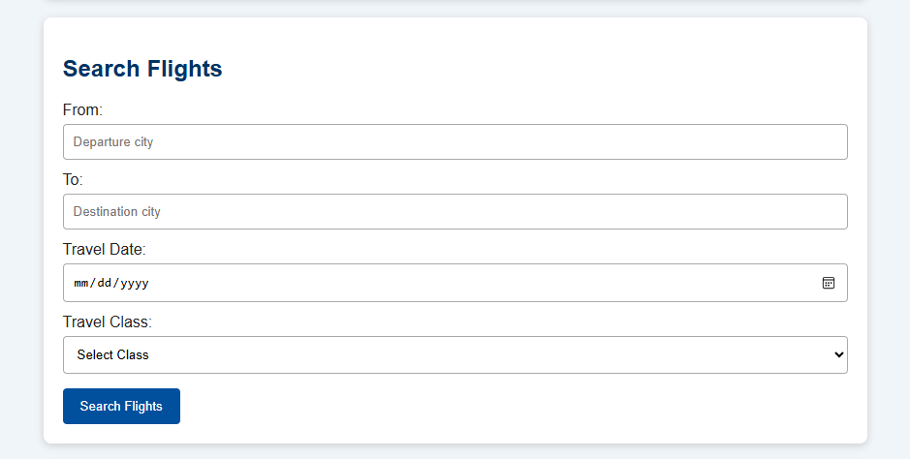
RESULT
Thus, the Online Flight Reservation System was designed successfully using HTML and CSS. The website provides user login, password recovery, flight search, ticket booking, payment selection, booking status, ticket printing, ticket cancellation, customer feedback, and administrator management sections. The responsive layout supports different screen sizes

